CCGPS
Frameworks
Student Edition

Mathematics

7th Grade
Unit 1: Operations with Rational Numbers

Unit 1
Operations with Rational Numbers

TABLE OF CONTENTS

Overview 3

Standards Addressed in this Unit 3
- Key Standards& Related Standards 3
- Standards for Mathematical Practice 4

Enduring Understandings 5

Concepts & Skills to Maintain 5

Selected Terms and Symbols 6

Tasks
- Show Me the Sign 8
- Hot Air Balloon 11
- Debits and Credits 16
- Using Positive and Negative Numbers in Context (FAL) 19
- Multiplying Rational Numbers 21
- Patterns of Multiplication and Division 24
- What does it cost? 28
- Field Trip Funding 29
- The Repeater vs. The Terminator 31
Appendix of Additional Resources 34
- Models for Teaching Operations of Integers 34

OVERVIEW
The units in this instructional framework emphasize key standards that assist students to develop a deeper understanding of numbers. They learn to express different representations of rational numbers (e.g., fractions, decimals, and percents) and interpret negative numbers in everyday context (e.g., sea level change). The big ideas that are expressed in this unit are integrated with such previous knowledge as estimation, mental and basic computation. All of these concepts need to be reviewed throughout the year.
The Evidence of Learning will tell you what your students will learn in this unit. Take what you need from the tasks and modify as required. These tasks are suggestions, something that you can use as a resource for your classroom.

KEY STANDARDS

Apply and extend previous understandings of operations with fractions to add, subtract, multiply and divide rational numbers.

MCC7.NS.1 Apply and extend previous understandings of addition and subtraction to add and subtract rational numbers; represent addition and subtraction on a horizontal or vertical number line diagram.

MCC7.NS.1a Describe situations in which opposite quantities combine to make 0.

MCC7.NS.1b Understand as the number located a distance from, in the positive or negative direction depending on whether is positive or negative. Show that a number and its opposite have a sum of 0 (are additive inverses). Interpret sums of rational numbers by describing real-world contexts.

MCC7.NS.1c Understand subtraction of rational numbers as adding the additive inverse, . Show that the distance between two rational numbers on the number line is the absolute value of their difference, and apply this principle in real-world contexts.

MCC7.NS.1d Apply properties of operations as strategies to add and subtract rational numbers.

MCC7.NS.2 Apply and extend previous understandings of multiplication and division of fractions to multiply and divide rational numbers.

MCC7.NS.2a Understand that multiplication is extended from fractions to rational numbers by requiring that operations continue to satisfy the properties of operations, particularly the distributive property, leading to products such as and the rules for multiplying signed numbers. Interpret products of rational numbers by describing real-world contexts.

MCC7.NS.2b Understand that integers can be divided, provided that the divisor is not zero, and every quotient of integers (with non-zero divisor) is a rational number. If and are integers then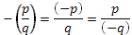. Interpret quotients of rational numbers by describing real-world contexts.

MCC7.NS.2c Apply properties of operations as strategies to multiply and divide rational numbers

MCC7.NS.2d Convert a rational number to a decimal using long division; know that the decimal form of a rational number terminates in 0’s or eventually repeats.

MCC7.NS.3 Solve real-world and mathematical problems involving the four operations with rational numbers.

STANDARDS FOR MATHEMATICAL PRACTICE

The Standards for Mathematical Practice describe varieties of expertise that mathematics educators at all levels should seek to develop in their students. These practices rest on important “processes and proficiencies” with longstanding importance in mathematics education. The first of these are the NCTM process standards of problem solving, reasoning and proof, communication, representation, and connections. The second are the strands of mathematical proficiency specified in the National Research Council’s report Adding It Up: adaptive reasoning, strategic competence, conceptual understanding (comprehension of mathematical concepts, operations and relations), procedural fluency (skill in carrying out procedures flexibly, accurately, efficiently and appropriately) and productive disposition (habitual inclination to see mathematics as sensible, useful, and worthwhile, coupled with a belief in diligence and one’s own efficacy).

(Practices to be explicitly emphasized in this unit are indicated with an *.)

*1. Make sense of problems and persevere in solving them.

Students explain and demonstrate rational number operations by using symbols, visuals, words, and real life contexts. Students demonstrate perseverance while using a variety of strategies (number lines, manipulatives, drawings, etc.

*2. Reason abstractly and quantitatively.
Students demonstrate quantitative reasoning by representing and solving real world situations using visuals, numbers, and symbols. They demonstrate abstract reasoning by translating numerical sentences into real world situations.

*3. Construct viable arguments and critique the reasoning of others.
Students will discuss rules for operations with rational numbers using appropriate terminology and tools/visuals. Students apply properties to support their arguments and constructively critique the reasoning of others while supporting their own position.

4. Model with mathematics. Students model understanding of rational number operations using tools such as algebra tiles, counters, visuals, and number lines and connect these models to solve problems involving real-world situations.

5. Use appropriate tools strategically. Students demonstrate their ability to select and use the most appropriate tool (paper/pencil, manipulatives, and calculators) while solving problems with rational numbers.

6. Attend to precision. Students demonstrate precision by using correct terminology and symbols and labeling units correctly. Students use precision in calculation by checking the reasonableness of their answers and making adjustments accordingly.

7. Look for and make use of structure. Students look for structure in positive and negative rational numbers when they place them appropriately on the number line. They use this structure in calculation when considering the position of numbers on the number line. In addition, students recognize the problem solving structures of word problems and use this awareness to aid in solving them.

8. Look for and express regularity in repeated reasoning. Students will use manipulatives to explore the patterns of operations with rational numbers. Students will use these patterns to develop algorithms. They can use these algorithms to solve problems with a variety of problem solving structures.

(Adapted from Illinois’ Curriculum Model)

ENDURING UNDERSTANDINGS

- Computation with positive and negative numbers is often necessary to determine relationships between quantities.
- Models, diagrams, manipulatives and patterns are useful in developing and remembering algorithms for computing with positive and negative numbers.
- Properties of real numbers hold for all rational numbers.
- Positive and negative numbers are often used to solve problems in everyday life.

CONCEPTS AND SKILLS TO MAINTAIN

Connections to Previous Learning: In Grade 6, students develop an understanding of rational numbers by using vertical and horizontal number lines and by applying their previous knowledge of whole numbers and integers to rational number systems.

Students have a great deal of background in operations from K-6 that will lead to achievement of the expectations in this unit. In the primary grades, students build understanding of whole number addition and subtraction. In the intermediate grades, students build understanding of multiplication and division with whole numbers and addition, subtraction, multiplication and division with fractions and decimals. 6th grade students learn to divide fractions by fractions with understanding and work to build an understanding of the value of integers. All of these concepts are crucial for students to be successful in this unit on operations with rational numbers. In the past, students have used number line models with whole numbers, fractions and decimals. 6th graders have represented integers on vertical and horizontal number line diagrams, but this is their first experience in adding and subtracting positive and negative rational numbers.

Focus of this Unit: Students will be able to add, subtract, multiply, and divide rational numbers fluently as well as solve real-world and mathematical problems. In this unit, students will represent their calculations using number line models, equations or expressions, and real world applications.

Connections to Subsequent Learning: Students will use their understanding of rational numbers and apply them to linear functions.

(Adapted from Illinois’ Curriculum Unit 3: Rational Number Operations)

SELECTED TERMS AND SYMBOLS

The following terms and symbols are often misunderstood. These concepts are not an inclusive list and should not be taught in isolation. However, due to evidence of frequent difficulty and misunderstanding associated with these concepts, instructors should pay particular attention to them and how their students are able to explain and apply them.

The definitions below are for teacher reference only and are not to be memorized by the students. Students should explore these concepts using models and real life examples. Students should understand the concepts involved and be able to recognize and/or demonstrate them with words, models, pictures, or numbers.

The websites below are interactive and include a math glossary suitable for middle school students. Note – Different sources use different definitions. Please preview any website for alignment to the definitions given in the frameworks. The definitions below are from the CCSS glossary http://www.corestandards.org/Math/Content/mathematics-glossary/glossary, when applicable.

Visit http://intermath.coe.uga.edu or http://mathworld.wolfram.com to see additional definitions and specific examples of many terms and symbols used in grade 7 mathematics.

- Additive Inverse: Two numbers whose sum is 0 are additive inverses of one another. Example: 3/4 and – 3/4 are additive inverses of one another because 3/4 + (– 3/4) = (– 3/4) + 3/4 = 0.

- Multiplicative Inverse: Two numbers whose product is 1 are multiplicative inverses of one another.
Example: 3/4 and 4/3 are multiplicative inverses of one another because 3/4 4/3 =
4/3 3/4 = 1.

- Absolute Value: The distance between a number and zero on the number line. The symbol for absolute value is shown in this equation: = 8

- Integers: A number expressible in the form a or –a for some whole number a. The set of whole numbers and their opposites {…-3, -2, -1, 0, 1, 2, 3…}

- Long Division: Standard procedure suitable for dividing simple or complex multi-digit numbers. It breaks down a division problem into a series of easier steps.

- Natural Numbers: The set of numbers {1, 2, 3, 4,…}. Natural numbers can also be called counting numbers.

- Negative Numbers: The set of numbers less than zero.

- Opposite Numbers: Two different numbers that have the same absolute value. Example: 4 and -4 are opposite numbers because both have an absolute value of 4.

- Positive Numbers: The set of numbers greater than zero.

- Rational Numbers: The set of numbers that can be written in the form a/b where a and b are integers and b 0.

- Repeating Decimal: A decimal number in which a digit or group of digits repeats without end.

- Terminating Decimal: A decimal that contains a finite number of digits.

- Zero Pair: Pair of numbers whose sum is zero.

SE Learning Task: Show Me Your Sign

Number lines and counters are useful in demonstrating understanding of operations with integers.

1. Find four pairs of integers with a sum of 5. Explain what method you used to find the pairs.
(Use positive integers only.)
Models Integer |  | Sum | Equation | Method
2. What do you notice about these integers? How are they related?

3. Find four pairs of integers with a sum of 5. Explain your process.
(Use at least one positive integer and at least one negative integer for each pair of integers.)
Model Integers |  | Sum | Equation | Method
4. What do you notice about these integers? How are they related?

5. Find a pair of negative integers with a sum of 5. What do you notice about the result? Explain your findings.

6. Find five pairs of integers with a sum of -6. What do you notice about each pairs of integers?
(Use at least one positive integer and one negative integer for each pair of integers.)

7. What do you notice when adding integers?
Look at your results from problems 1-6 to help you.

For the following examples, write an equation (show numerically)and draw a model using a number line or colored counters to help explain your answer.

8. Explain (-2) + 5.

9. Explain 7 + 8.

10. Explain (-3) + (-4).

11. Explain 5 + (-8).

12. Explain a + b if both a and b are positive numbers.

13. Explain (a) + (b) if (a) and (b) both represent negative numbers.

14. Explain a + (b) if a represents any positive number and (b) represents any negative
number.

15. Explain b + (a) if b represents any positive number and (a) represents any negative number.

16. Explain 2 + 8 + (-7).

17. Explain a + b + c if a and b represent positive numbers and(c) represents a negative number.

SE Learning Task: Hot Air Balloons: MCC7.NS.1
- Model with mathematics and use tools strategically: Make a balloon model and vertical number line.

When using hot air balloons to add or subtract integers, there are several important things to remember. They are:
- The first number indicates where the balloon starts.
- The sign tells you if you will be adding or subtracting something from the balloon. An addition sign tells you that you will be adding something to the hot air balloon and a subtraction sign tells you that you will be subtracting something from the balloon
- The second number tells you what you will add or subtract from the balloon (either bags of gas if the number is positive or bags of sand if the number is negative).

II. Reason quantitatively: What happens to the balloon when… |  | Mathematically
Add bags of gas | Fill in the blanks: (up or down)  Balloon goes ________ | Fill in the blanks: ( + or - )  3 bags of gas (___3)  10 bags of gas (___10)
Add bags of sand | Balloon goes ________ | 3 bags of sand (____3)  10 bags of sand (____10)
Subtract bags of gas | Balloon goes ________ | Subtract 3 bags of gas___(___3)  Subtract 10 bags of gas ___(__10)
Subtract bags of sand | Balloon goes ________ | Subtract 3 bags of sand __(__3)  Subtract 10 bags of sand ___(___10)

III. Make sense of problems: Use a number line and a model of a hot air balloon. Model each problem and answer the questions that follow; the first one gives you hints as to the types of answers you should give.

- Where does the balloon start? (#)________
- Do you add or subtract something from the balloon? (operation)_________________
- What do you add or subtract from the balloon? (# bags of ?)_______________________
- Where does the balloon end up? (#)__________

- Where does the balloon start?___________
- Do you add or subtract something from the balloon?______________
- What do you add or subtract from the balloon?__________________________________
- Where does the balloon end up?_______________

- Where does the balloon start?________________
- Do you add or subtract something from the balloon?________________________
- What do you add or subtract from the balloon?__________________________________
- Where does the balloon end up?_______________

- What do you think happens to the balloon if you take away sand instead of adding sand?
________________________________________________________________________

- Where does the balloon start?________________
- Do you add or subtract something from the balloon?______________________________
- What do you add or subtract from the balloon?__________________________________
- Where does the balloon end up?_______________

- What do you think happens to the balloon if you take away gas bags instead of adding gas bags?
________________________________________________________________________

- Where does the balloon start?_______________
- Do you add or subtract something from the balloon?______________________________
- What do you add or subtract from the balloon?__________________________________
- Where does the balloon end up?_______________

- Where does the balloon start?________________
- Do you add or subtract something from the balloon?______________________________
- What do you add or subtract from the balloon?__________________________________
- Where does the balloon end up?_______________

IV. Model and construct arguments: Model the following with your balloon and number line to answer each. Describe what you did with the air balloon. Be sure to include where you began, whether you added or subtracted bags, what types of bags, and your ending point in relation to your starting point.

27.

______________________________________________________________________________

28.

______________________________________________________________________________

29.

______________________________________________________________________________

30.

______________________________________________________________________________

31.

______________________________________________________________________________

32. 2 + 8 + (-7)

______________________________________________________________________________

V. Making generalizations about patterns: For the following questions, look for patterns that you discovered in sections I-IV. Model the following with your balloon and number line to answer each. Describe what you did with the air balloon. Be sure to include where you began, whether you added or subtracted bags, what types of bags, and your ending point in relation to your starting point.

Sample: If a and b are positive numbers, explain a+b
I will begin with my balloon above zero to represent a on the number line. Next, I would continue to move my balloon further up on the number line to represent the addition of a positive number (b). This models adding a gas bag to my balloon. My final destination would definitely be above zero on the number line, making my final answer positive.
33. If a and b are positive numbers, explain (-a) + (-b)

34. If a and b are positive numbers, explain a + (-b)

35. If a and b are positive numbers, explain a - (-b)

36. If a and b are positive numbers explain a - b

37. If a and b are positive numbers explain (-a) - (-b)

38. If a and b are positive numbers explain (-a) + b

39. If a, b, and c are all positive numbers, explain a + b + (-c)

40. You may have noticed that there are two sets of explanations in section V. They are very similar. Examine the explanations for the sample question and #33-38. Determine the two pairs that require the same movement on the number line and explain what they have in common.

VI. Express regularity in repeated reasoning: Now, that you have completed the section V. questions, you can investigate some conjectures.

41. What happened when you were adding integers that had the same signs; (-a) + (-b) and
a + b?

42. What rule can you make by your discovery? Explain.

43. What happened when you were adding integers that have different signs (a positive integer and a negative integer: (-a) + b and a + (-b))?

44. What rule can you make by your discovery? Explain.

SE Performance Task: Debits and Credits

Suppose you have been given a checkbook. Your checkbook has a ledger for you to record your transactions. There are two types of transactions that may take place, (1) deposits (money placed in the account) and (2) debits/ payments (money –which you spend and it comes out of the account). The difference between debits and the deposits tells the value of the account. If there are more credits than debits, the account is positive, or “in the black”. “in the black.” If there are more debits than credits, the account is in debt, shows a negative cash value, or is “in the red.”

Vocabulary key –
Transaction = debit or credit from an account
Debit (withdrawl) = Check or debit card usage written out of the checking account
Credit= Deposit of money put in the account

Situation #1:
Use the ledger to record the information and answer the questions.
Note: On August 12, your beginning balance is $0.00
1. On August 16, you receive a check from your Grandmother for $40 for your birthday.
2. On August 16, you receive a check from your Parents for $100 for your birthday.
3. On August 17, you purchase a pair of pants from Old Navy for $23.42.
4. On August 18, you find $5.19 in change during the day.
5. On August 19, you purchase socks from Wal-Mart for $12.76.

DATE | TRANSACTION | PAYMENT (-) | DEPOSIT (+) | BALANCE
8/16 | Beginning balance |  |  | $0.00

A. What is your balance after five transactions?

B. How much money did you deposit (show as a positive value)?

C. How much money did you pay or withdraw (show as a negative value)?

Situation #2:
Use the ledger to record the information and answer the questions.
Note: On May 5, your beginning balance is $8.00
1. On May 6, you spent $4.38 on a gallon of ice cream at Marty’s Ice Cream Parlor.
2. On May 7, you spent $3.37 on crackers, a candy bar, and a coke from Circle H convenience store.
3. On May 8, you received $10 for cutting the neighbor’s grass.
4. On May 8, you spent $14.80 on a downloaded book for your Kindle.

DATE | TRANSACTION | PAYMENT (-) | DEPOSIT (+) | BALANCE

A. What is your balance after four transactions?

B. How much money did you deposit (show as a positive value)?

C. How much money did you pay or withdraw (show as a negative value)?

D. Can you really afford to spend $14.80 on a book for your Kindle? If not, how much money do you need to earn to have an account balance of $0?

Situation #3:
Use the ledger to record the information and answer the questions.
Note: On July 4, your beginning balance is (-$40).

Requirements:
- Use at least eight transactions, four of which are debits and four are credits.
- You must have an ending balance of $145.
- You must include debit and credit amounts that have cents in at least five of your transactions.
Be sure to fill out the ledger as you go.

DATE | TRANSACTION | PAYMENT (-) | DEPOSIT (+) | BALANCE

Formative Assessment Lesson: Using Positive and Negative Numbers in Context
(Concept Development)
This lesson unit is intended to help you assess how well students are able to understand and use directed numbers in context. It is intended to help identify and aid students who have difficulties in ordering, comparing, adding, and subtracting positive and negative integers.

Source: Formative Assessment Lesson Materials from Mathematics Assessment Project

http://map.mathshell.org/materials/download.php?fileid=1304

STANDARDS ADDRESSED IN THIS TASK

Apply and extend previous understandings of operations with fractions to add, subtract, multiply, and divide rational numbers.
MCC7.NS.1 Apply and extend previous understandings of addition and subtraction to add and subtract rational numbers; represent addition and subtraction on a horizontal or vertical number line diagram.
MCC7.NS.1a Describe situations in which opposite quantities combine to make 0.
MCC7.NS.1b Understand as the number located a distance from , in the positive or negative direction depending on whether is positive or negative. Show that a number and its opposite have a sum of 0 (are additive inverses). Interpret sums of rational numbers by describing real-world contexts.
MCC7.NS.1c Understand subtraction of rational numbers as adding the additive inverse, . Show that the distance between two rational numbers on the number line is the absolute value of their difference, and apply this principle in real-world contexts.
MCC7.NS.1d Apply properties of operations as strategies to add and subtract rational numbers.
MCC7.NS.3 Solve real-world and mathematical problems involving the four operations with rational numbers.

STANDARDS FOR MATHEMATICAL PRACTICE
This lesson uses all of the practices with emphasis on:
1. Make sense of problems and persevere in solving them
2. Reason abstractly and quantitatively.
4. Model with mathematics.
7. Look for and make use of structure.

ESSENTIAL QUESTIONS

- How can integer models be implemented to show changes in temperatures?
- How can we demonstrate our understanding of operations with integers through comparisons between different cities in the world?

TASK COMMENTS

Tasks and lessons from the Mathematics Assessment Project are specifically designed to help teachers effectively formatively assess their students. The way the tasks and lessons are designed gives the teacher a clear understanding of what the students are able to do and not do. Within the lesson, teachers will find suggestions and question prompts that will help guide students towards understanding. For more information access the MAP website:
http://www.map.mathshell.org/materials/background.php?subpage=formative

The task, Using Positive and Negative Numbers in Context, is a Formative Assessment Lesson (FAL) that can be found at the website: http://map.mathshell.org/materials/lessons.php?taskid=453&subpage=concept

The FAL document provides a clear lesson design, from the opening of the lesson to the closing of the lesson.

The PDF version of the task can be found at the link below:
http://map.mathshell.org/materials/download.php?fileid=1304

SE Learning Task: Multiplying Rational Numbers

Today we are going to use runners as our example to show how we can multiply positive and negative numbers using a number line. The rules for running along the number line are as follows:
• Running to the left or west means running in a negative direction
• Time in the past is represented by a negative value.

• Running to the right or east means running in positive direction.
• Time in the future is represented by a positive value.

- Jonas runs 5 meters per second to the right. Where was he 10 seconds later?

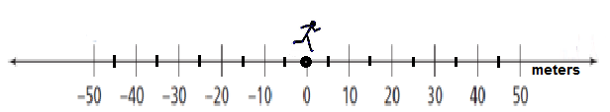
Number Sentence( )( ) = ( )_

- Dwayne ran 5 meters per second to the right. Where was he 5 seconds ago?
Number Sentence__( )( ) = ( )___

- Ariel runs west at 4 meters per second, where is she 10 seconds from now?
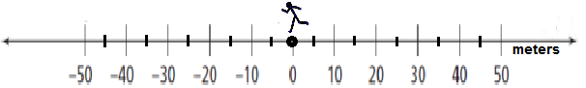
Number Sentence__( )( ) = ( )____

- Paul runs west at 6 meters per second, where was he 5 seconds ago?
Number Sentence__( )( ) = ( )___

Multiplying Using the Number Line Model

Try these problems on your own.

In the city of Mathematica, there is a town center which attracts many visitors to the city. From the town center, a train takes visitors to different popular locations. The map shows a few favorite destinations that people like to visit. Answer the following problems about traveling around the city.

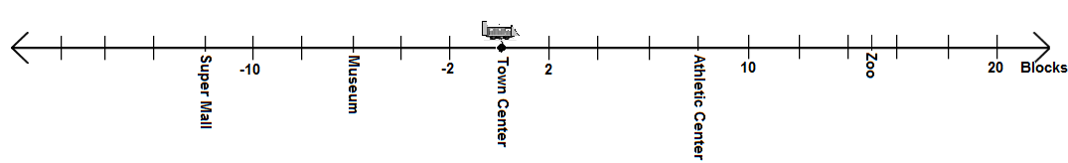
The rules for moving along the number line are as follows:
- Moving to the left or west means moving in a negative direction.
- Moving to the right or east means moving in positive direction.
- Time in the future is represented by a positive value.
- Time in the past is represented by a negative value.

- The train leaves Town Center traveling east at the speed of 2 blocks per minute. How many blocks will you be in 4 minutes? Where will you be in 4 minutes?

- The train leaves the Town Center going west at 2blocks per minute. What popular location will you arrive at in 6 minutes? How many blocks away from the Town Center will you be?

- The train passes through the Town Center going east at 2 blocks per minute. Where was that train 3 minutes ago?

- You would like to take the train to the Zoo from the Town Center. How many minutes will this take if the train travels 2 blocks per minute? Write a math sentence to represent this scenario.

- You waited 4 minutes for the train to arrive. The train was traveling west at 2 blocks per minute. Where was the train?

Let’s look to see if there are any patterns.

- When you moved east (right) and it was time in the future, two positive numbers represented the situation. What was the result on the number line when moving east and moving in the future occurred? Was the result of multiplying positive or negative? Is this always true?

- When you moved east (right) and it was time in the past, a positive number and a negative number represented the situation. What was the result on the number line when moving east and moving in the past occurred? Was the result of multiplying positive or negative? Is this always true?

- When you moved west (left) and it was time in the future, a negative number and a positive numbers represented the situation. What was the result on the number line when moving west and moving in the future occurred? Was the result of multiplying positive or negative? Is this always true?

- When you moved west (left) and it was time in the past, two negative numbers represented the situation. What was the result on the number line when moving west and moving in the past occurred? Was the result of multiplying positive or negative? Is this always true?

- What multiplication patterns can you see from each situation? Fill in the chart below according to the signs of the factors and products.

Factor | Factor | Product
+ number |  | + number
 | (-) number | (-) number
+ number |  | (-) number
 | (-) number | + number

SE Learning Task: Patterns of Multiplication and Division

You have recently practiced dividing positive and negative integers on a number line. It is now your turn to model how to divide. Below are “hints” to help you get started.

When you divide, keep in mind these simple steps:

- Identify the dividend on the number line.
- Look at the divisor, is it positive (yellow with right arrow) or negative (red with left arrow).
- Determine how many times the divisor will have to move forward (+) or backward (-) to equal the dividend.
- The number of times it must move and the type of movement determine the answer.

Model the following on the number line.
- What is the dividend? __________

- What is the divisor? __________
- What is the solution and how did you find it?

___________________________________________________________________________

- What is the dividend? __________

- What is the divisor? __________

- What is the solution and how did you find it?

___________________________________________________________________________

- What is the dividend? __________

- What is the divisor? __________

- What is the solution and how did you find it?

___________________________________________________________________________

- What is the dividend? __________

- What is the divisor? __________

- What is the solution and how did you find it?

___________________________________________________________________________

- What is the dividend? __________

- What is the divisor? __________

- What is the solution and how did you find it?

___________________________________________________________________________

- What is the dividend? __________

- What is the divisor? __________

- What is the solution and how did you find it?

___________________________________________________________________________

- What is the dividend? __________

- What is the divisor? __________

- What is the solution and how did you find it?

___________________________________________________________________________

Let’s look to see if there are any patterns.

- When given a positive integer as the dividend…
  - What was the result of dividing by a positive integer?

  - What was the result of dividing by a negative integer?

- When given a negative integer as the dividend…
  - What was the result of dividing by a positive integer?

  - What was the result of dividing by a negative integer?

- Fill in each table below. Are the patterns the same as the multiplication patterns? Explain your findings.

Multiplication Patterns | Factor | Factor | Product
 | + number |  | + number
 |  | (-) number | (-) number
 | + number |  | (-) number
 |  | (-) number | + number

Division  Patterns | Dividend | Divisor | Divisor
 |  | + number | + number
 | (-) number |  | (-) number
 | + number |  | (-) number
 |  | (-) number | + number

SE Performance Task: What does it cost?

Solve this problem:
A warehouse sells clothing at a fraction of its original cost. The table below shows the fraction off the original price for clothing that remains in the warehouse after 10 days, 20 days, and 30 days.

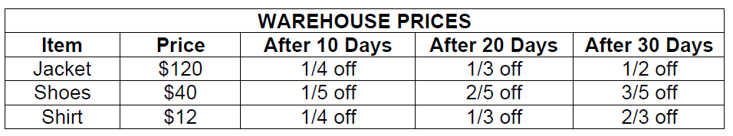

- Find the price of the items after each 10-day period to complete the chart below. Show how you arrived at each answer.

WAREHOUSE PRICES
ITEM | PRICE | AFTER 10 DAYS | AFTER 20 DAYS | AFTER 30 DAYS
Jacket | $120 | $90.00
Shoes | $40
Shirt | $12 |  |  | $4.00

Suppose you have $100 to spend…
- Within the range of $90.00 to $100.00, what are all possible combinations of items you could buy after 10 days?

- Would you have enough money to buy 2 jackets after 20 days? Justify your solution.

- Could you buy all 3 items if you waited until after 30 days? Remember, you only have $100 to spend. Justify your answer.

- Jackets cost the retailer $75 a piece to purchase wholesale. If he has five to sell and doesn’t sell them until 30 days have gone by, how much money does he lose? Remember a loss is shown with a negative rational number.

SE PERFORMANCE TASK: Field Trip Funding

Mr. Richards, a teacher from Bosworth School, plans to take 30 students on a school trip. Here are the places they could visit.

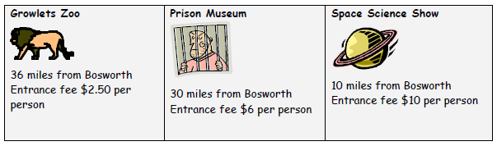

The class votes on which place to visit. Here are the results.
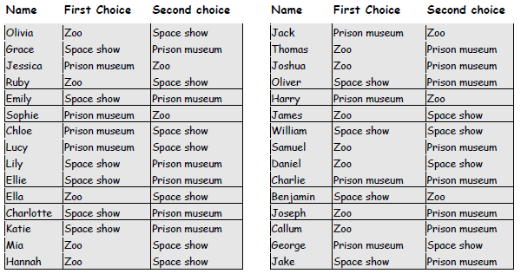
Further Facts About the Trip:
- Buses cost $6.00 per mile
- The school fund will pay the first $200 of the trip.
- Teachers will go for free.
- Each student will pay the same amount for the trip.

Answer the following questions based on your given data.
- Taking both first and second choices into account, where should they go for the trip? Explain clearly how you came to your decision.

- How much will each person need to pay to go on the trip you have chosen? Explain carefully how you decide?

- Which trip would be the least expensive? How much would it cost per student?

SE Learning Task: THE REPEATER vs. THE TERMINATOR

Part One
The chart below includes 13 unit fractions, fractions with a numerator of 1. For this activity, first determine the prime factorization of the denominator of the unit fraction. Then, turn the fraction into a decimal and determine whether the fraction is repeating or terminating.

UNIT FRACTION | PRIME FACTORIZATION OF DENOMINATOR | DECIMAL FORM | TERMINATES  OR  REPEATS
 | PRIME | .5 | Terminates
 | PRIME |  | Repeats
 |  |  | Terminates
 |  |  | Repeats
 |  | .
 |  |  | Terminates
 | PRIME

Answer the following questions based upon your results from the chart.
- Which fractions terminate?

- What do you notice about the types of fractions that can be turned into terminating decimals? (Hint: Look at the prime factorization of the denominators)

- Give another example of a fraction that can be turned into a terminating decimal. Justify why this fraction is a terminating decimal.

- Consider the fractions. What do these fractions have in common?

- What can you conclude about rational numbers with denominators that are prime numbers?

Part Two
Convert the following fractions into decimals. (You have calculated a few of them before!)
Fraction | Decimal | Fraction | Decimal | Fraction | Decimal | Fraction | Decimal

- Do you notice a pattern between the fractions with denominators of 11 and their decimals? If so, what is the pattern?

- Without using a calculator, what is the decimal form of $\frac{8}{9}$?

- Do you notice a pattern between the fractions with denominators of 9 and their decimals? If so, what is the pattern?

- Without using a calculator, what is the decimal form of $\frac{9}{11}$?

APPENDIX OF ADDITIONAL RESOURCES

Models for Teaching Operations of Integers

These models have been adapted from http://teachers.henrico.k12.va.us/math/hcpsalgebra1/.

The following are some everyday events that can be used to help students develop a conceptual understanding of addition and subtraction of integers.

- Using a credit card example can make this subtraction concept clearer. If you have spent
money you don't have (-5) and paid off part of it (+3), you still have a negative balance (-2) as a debt, or (-5) + 3 = (-2).

- Draw a picture of a mountain, the shore (sea level) and the bottom of the ocean. Label sea level as 0.

Any of the following models can be used to help students understand the process of adding or subtracting integers. If students have trouble understanding and using one model you can show students how to use another model.

- The Charged Particles Model (same as using two-color counters)

When using charged particles to subtract,
3 – (-4) for example, you begin with a picture of 3 positive particles.
Since there are no negative values to “take away”, you must use the Identity Property of Addition to rename positive 3 as 3 + 0. This is represented by 4 pairs of positive and negative particles that are equivalent to 4 zeros. | 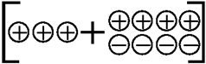
Now that there are negative particles, you can “take away” 4 negative particles. | 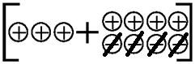
The modeled problem shows that the result of subtracting 4 negative particles is actually like adding 4 positive particles. The result is 7 positive particles. This is a great way to show why  3 – (-4) = 3 + 4 = 7 | 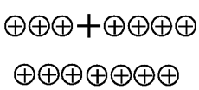

Two-Color Counters Method
When using two-colored counters you would use the yellow side to represent positive integers and the red side to represent negative numbers.  The problem represented is -3 – 5. | 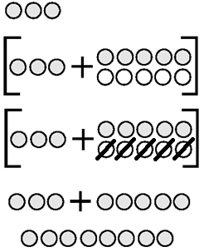

- The Stack or Row Model

To model positive and negative integers, use colored linking cubes and graph paper. Graph paper and colored pencils will allow students to record problems and results. Students should also write the problems and answers numerically.
Create stacks or rows of numbers with the colored linking cubes and combine/compare the cubes. If the numbers have the same sign, then the cubes will be the same color. Stress that adding is like combining, so make a stack or row to show this. | 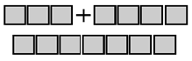 (-3) + (-4) = (-7)
If the numbers are not the same sign (color), for example -3 + 5, you compare the stacks of  different colors.Using the concept of zero pairs, the result is the difference between the stacks or the result is based on the higher stack. This is easy to see and understand. | 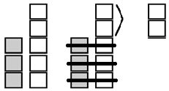
For subtraction you create zeros by pairing one of each color. Then add as many zeros to the first number as needed so that you can take away what the problem calls for. Now physically take away the indicated amount and see what is left.  The example problem shown is 3 – (-4). | 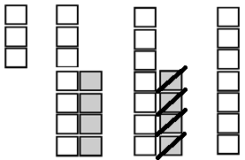

- The Hot Air Balloon Model

Sand bags (negative integers) and Hot Air bags (positive integers) can be used to illustrate operations with integers. Bags can be put on (added to) the balloon or taken off (subtracted).
Here is an example: -3 - (-4) = ?  - The balloon starts at -3 (think of the balloon being 3 feet below sea level or 3 feet below the level of a canyon) and you take off 4 sand bags.  - Now, think about what happens to a balloon if you  remove sand bags, the balloon gets lighter. So, the balloon would go up 4 units.  If you think in terms of a vertical number line, it would start at -3 and end up at 1, so -3 - (-4) = 1. To help students make the connection between -3 - (-4) and -3 + (+4), present the addition and subtraction questions using the same numbers. | 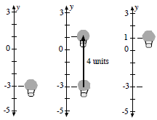
Another example would include the first addition question as 9 + (-5) and the first subtraction question
would then be 9 - (+5). The students see that putting on 5 sand bags (negative) produces the same result as taking off 5 hot air bags (positive).
- The Number Line Model

You can describe addition and subtraction of integers with a number line and a toy car. The car faces forward (to the right) to represent a positive direction. The car is moved forward to represent a positive integer. The car flips around backward (facing left) to represent a negative direction or subtraction. The car is moved backward (reverse) to represent a negative integer.
Example 1: 4 + 4 = 8

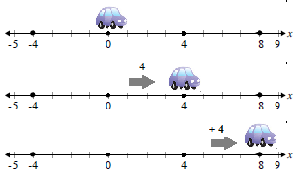
Example 2: 4 + (- 8) = -4
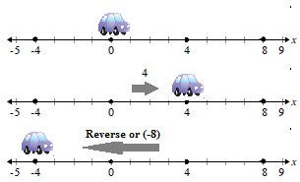
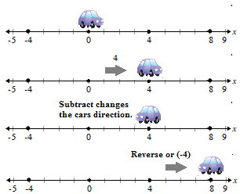Example 3: 4 – (-4) = 8

- Charged Particle Model for Multiplication

The charged particle method can be used to illustrate multiplication of integers.
To begin, a model with a 0 charge is illustrated. The 0 charge model will allow us to work with positive and negative integers.  Example 1: In this problem, 3 x (-2), three groups of two negative charges is added to the 0 charged field. The result is (-6). | 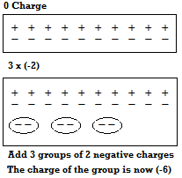
Example 2: (-3) x (-2) = ? | 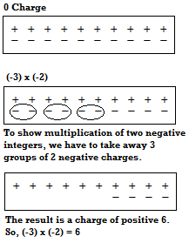

For more resources of multiplication and division of integers, see pages 144 – 146 of
Van de Walle, J., & Lovin, L.H. (2006). Teaching student-centered mathematics: Grades 5-8.
Boston, MA: Pearson Education and Allyn & Bacon

