

**CCGPS**

**Frameworks**

**Student Edition**

**Mathematics**



**UNIT 2**

**EXPRESSIONS AND EQUATIONS**

**TABLE OF CONTENTS**

Overview3

Standards Addressed in this Unit3

Key Standards & Related Standards3

The Standards for Mathematical Practice5

Enduring Understandings6

Concepts & Skills to Maintain6

Selected Terms and Symbols6

Tasks

* Distributing and Factoring Using Area 8
* Area & Algebra10
* Algebra Magic13
* Building and Solving Equations (FAL)15
* Geology Rocks Equations17
* Deconstructing Word Problems20
* Steps to Solving Equations (FAL)22
* T.V. Time and Video Games24

**OVERVIEW**

The units in this instructional framework emphasize key standards that assist students to develop a deeper understanding of numbers. They learn to express different representations of rational numbers (e.g., fractions, decimals, and percent’s), learn how to solve multi- step equations and discuss the difference between equations and expressions. The Big Ideas that are expressed in this unit are integrated with such routine topics as estimation, mental and basic computation.  All of these concepts need to be reviewed throughout the year.

The Evidence of Learning will tell you what your students will learn in this unit.  Take what you need from the tasks and modify as required.  These tasks are suggestions, something that you can use as a resource for your classroom.

**STANDARDS ADDRESSED IN THIS UNIT**

**KEY STANDARDS**

**MCC7.EE.1** Apply properties of operations as strategies to add, subtract, factor, and expand linear expressions with rational coefficients.

**MCC7.EE.2** Understand that rewriting an expression in different forms in a problem context can shed light on the problem and how the quantities in it are related. *For example, a* + 0.05*a* = 1.05*a* *means that “increase by 5%” is the same as “multiply by 1.05.”*

**MCC7.EE.3** Solve multi‐step real‐life and mathematical problems posed with positive and negative rational numbers in any form (whole numbers, fractions, and decimals), using tools strategically. Apply properties of operations as strategies to calculate with numbers in any form; convert between forms as appropriate; and assess the reasonableness of answers using mental computation and estimation strategies. *For example: If a woman making $25 an hour gets a 10% raise, she will make an additional $1/{10}$ of her salary an hour, or $2.50, for a new salary of $27.50. If you want to place a towel bar* 9 ${3 }/{4 }$*inches long in the center of a door that is* 27 $1/{2 }$*inches wide, you will need to place the bar about 9 inches from each edge; this estimate can be used as a check on the exact computation.*

**MCC7.EE.4** Use variables to represent quantities in a real‐world or mathematical problem, and construct simple equations and inequalities to solve problems by reasoning about the quantities.

**MCC7.EE.4a** Solve word problems leading to equations of the form *px + q = r* and *p(x+q) = r*, where *p*, *q*, and *r* are specific rational numbers. Solve equations of these forms fluently. Compare an algebraic solution to an arithmetic solution, identifying the sequence of the operations used in each approach. *For example, the perimeter of a rectangle is 54 cm. Its length is 6 cm. What is its width?*

**MCC7.EE.4b** Solve word problems leading to inequalities of the form *px + q > r* or *px + q < r*, where *p*, *q*, and *r* are specific rational numbers. Graph the solution set of the inequality and interpret it in the context of the problem. *For example, as a salesperson, you are paid $50 per week plus $3 per sale. This week you want your pay to be at least $100. Write an inequality for the number of sales you need to make, and describe the solutions.*

**RELATED STANDARDS**

**MCC7.NS.1** Apply and extend previous understandings of addition and subtraction to add and subtract rational numbers; represent addition and subtraction on a horizontal or vertical number line diagram.

**MCC7.NS.1a** Describe situations in which opposite quantities combine to make 0. *For example, a hydrogen atom has 0 charge because its two constituents are oppositely charged.*

**MCC7.NS.1b** Understand *p + q* as the number located a distance |*q*| from *p*, in the positive or negative direction depending on whether *q* is positive or negative. Show that a number and its opposite have a sum of 0 (are additive inverses). Interpret sums of rational numbers by describing real‐world contexts.

**MCC7.NS.1c** Understand subtraction of rational numbers as adding the additive inverse, *p – q = p + (-q)*. Show that the distance between two rational numbers on the number line is the absolute value of their difference, and apply this principle in real‐world contexts.

**MCC7.NS.1d** Apply properties of operations as strategies to add and subtract rational numbers.

**MCC7.NS.2** Apply and extend previous understandings of multiplication and division and of fractions to multiply and divide rational numbers.

**MCC7.NS.2a** Understand that multiplication is extended from fractions to rational numbers by requiring that operations continue to satisfy the properties of operations, particularly the distributive property, leading to products such as (-1)(-1) = 1 and the rules for multiplying signed numbers. Interpret products of rational numbers by describing real‐world contexts.

**MCC7.NS.2b** Understand that integers can be divided, provided that the divisor is not zero, and every quotient of integers (with non‐zero divisor) is a rational number. If *p* and *q* are integers then – *(p/q) = (-p)/q = p/(-q)*. Interpret quotients of rational numbers by describing real‐world contexts.

**MCC7.NS.2c** Apply properties of operations as strategies to multiply and divide rational numbers.

**MCC7.NS.2d** Convert a rational number to a decimal using long division; know that the decimal form of a rational number terminates in 0s or eventually repeats.

**MCC7.NS.3** Solve real‐world and mathematical problems involving the four operations with rational numbers.

**THE STANDARDS FOR MATHEMATICAL PRACTICE**

1. **Make sense of problems and persevere in solving them.** Students solve real world problems through the application of algebraic concepts. Students seek the meaning of a problem and look for efficient ways to represent and solve it. They may check their thinking by asking themselves, “What is the most efficient way to solve the problem?”, “Does this make sense?”, and “Can I solve the problem in a different way?”.
2. **Reason abstractly and quantitatively.** Students demonstrate quantitative reasoning by representing and solving real world situations using visuals, equations, inequalities and linear relationships into real world situations.
3. **Construct viable arguments and critique the reasoning of others.** Students will discuss the differences among expressions, equations and inequalities using appropriate terminology and tools/visuals. Students will apply their knowledge of equations and inequalities to support their arguments and critique the reasoning of others while supporting their own position.
4. **Model with mathematics.** Students will model an understanding of expressions, equations, inequalities, and graphs using tools such as algebra tiles/blocks, counters, protractors, compasses, and visuals to represent real world situations.
5. **Use appropriate tools strategically.** Students demonstrate their ability to select and use the most appropriate tool (pencil/paper, manipulatives, calculators, protractors, etc.) while rewriting/evaluating/analyzing expressions, solving and representing and analyzing linear relationships.
6. **Attend to precision.** Students demonstrate precision by correctly using numbers, variables and symbols to represent expressions, equations and linear relationships, and correctly label units. Students use precision in calculation by checking the reasonableness of their answers and making adjustments accordingly. Students will use appropriate algebraic language to describe the steps in rewriting expressions and solving equations.
7. **Look for and make use of structure.**  Students routinely seek patterns or structures to model and solve problems. Students apply properties to generate equivalent expressions (i.e. 6 + 2*x* = 2 (3 + *x*) by distributive property) and solve equations (i.e. 2*c* + 3 = 15, 2*c* = 12 by subtraction property of equality; c=6 by division property of equality).
8. **Look for and express regularity in repeated reasoning.** In grade 7, students use repeated reasoning to understand algorithms and make generalizations about patterns. During multiple opportunities to solve and model problems, they may notice that *a/b* ÷ *c/d* = *ad/bc* and construct other examples and models that confirm their generalization. They extend their thinking to include complex fractions and rational numbers.

**ENDURING UNDERSTANDINGS**

* Variables can be used to represent numbers in any type mathematical problem.
* Understand the difference in an expression and an equation.
* Write and solve multi-step equations including all rational numbers.
* Some equations may have more than one solution
* There are differences and similarities between equations and inequalities.

**CONCEPTS AND SKILLS TO MAINTAIN**

It is expected that students will have prior knowledge/experience related to the concepts and skills identified below. It may be necessary to pre-assess in order to determine if time needs to be spent on conceptual activities that help students develop a deeper understanding of these ideas.

* number sense
* computation with whole numbers and decimals, including application of order of operations
* addition and subtraction of common fractions with like denominators
* computation with all positive and negative rational numbers
* data usage and representations

**SELECTED TERMS AND SYMBOLS**

The following terms and symbols are often misunderstood. These concepts are not an inclusive list and should not be taught in isolation. However, due to evidence of frequent difficulty and misunderstanding associated with these concepts, instructors should pay particular attention to them and how their students are able to explain and apply them.

**The definitions below are for teacher reference only and are not to be memorized by the students.** Students should explore these concepts using models and real life examples. Students should understand the concepts involved and be able to recognize and/or demonstrate them with words, models, pictures, or numbers.

The websites below are interactive and include a math glossary suitable for middle school students. **Note – Different sources use different definitions. Please preview any website for alignment to the definitions given in the frameworks.** The definitions below are from the CCSS glossary <http://www.corestandards.org/Math/Content/mathematics-glossary/glossary>, when applicable.

Visit [http://intermath.coe.uga.edu](http://intermath.coe.uga.edu/) or [http://mathworld.wolfram.com](http://mathworld.wolfram.com/) to see additional definitions and specific examples of many terms and symbols used in grade 7 mathematics.

* **Algebraic expression**:  An expression consisting of at least one variable and also consist of numbers and operations.
* **Coefficient**:  The number part of a term that includes a variable.  For example, 3 is the coefficient of the term 3*x*.

**Constant**:  A quantity having a fixed value that does not change or vary, such as a number.  For example, 5 is the constant of *x* + 5.

* **Equation**:  A mathematical sentence formed by setting two expressions equal.
* **Inequality**:  A mathematical sentence formed by placing inequality symbol between two expressions.
* **Term**:  A number, a variable, or a product and a number and variable
* **Numerical expression**:  An expression consisting of numbers and operations.
* **Variable**:  A symbol, usually a letter, which is used to represent one or more numbers.

**SE Learning Task: Distributing and Factoring Area**

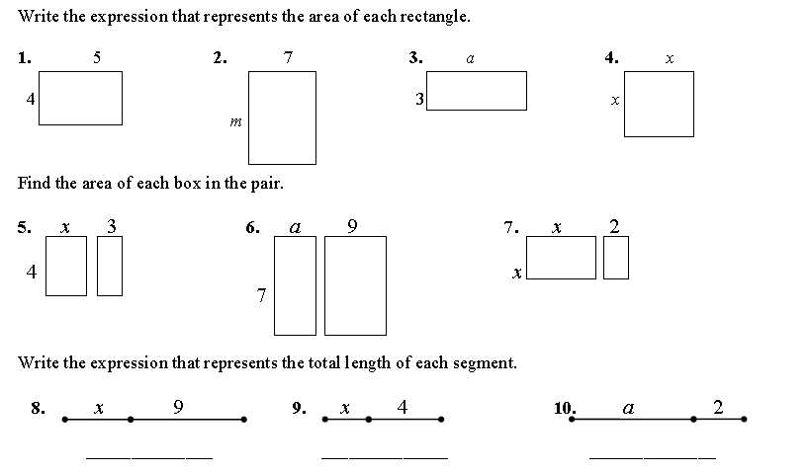

5

3

3

4

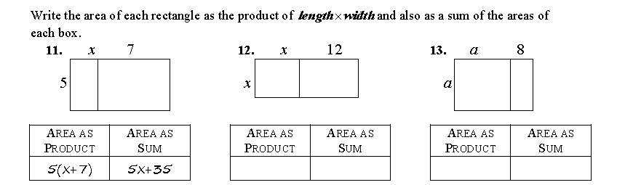

*Use the distributive property to find sums that are equivalent to the following expressions. (You may want to use a rectangle to help you)*

14. _____________ 15. ______________

16. ____________ 17. ______________

18. ______________ 19. ______________

20. ____________ 21. _____________

**Factoring Using Area Models**

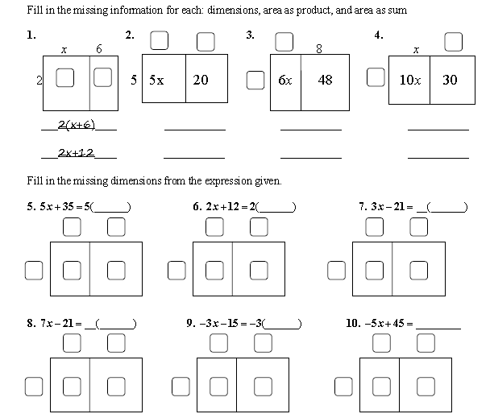

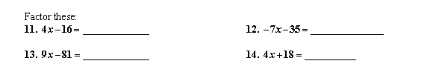*Use rectangles to factor the following problems:*

**SE Learning Task: Area and Algebra**

1. **Perimeter and Area of Figures**

*Find the perimeter and area of the following figures.* ***Explain in words how you found the perimeter and area of each figure.*** (unit: inches)

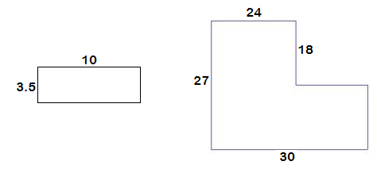Perimeter: _______________

Area: _______________

Explanation:

1. Perimeter: ______________



Area: ______________

Explanation:

1. **Perimeter of Algebraic Figures**

*Find the perimeter of each of the following figures.*

[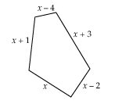](http://www.google.com/url?sa=i&rct=j&q=algebraic+expressions+perimeter&source=images&cd=&cad=rja&docid=ZM_hM1Bp6fU9YM&tbnid=K70KFCCsufK59M:&ved=0CAUQjRw&url=http://mdk12.org/instruction/clg/public_release/algebra_data_analysis/G1_E1_I3.html&ei=InCvUeL5DbGq4AOf04BA&psig=AFQjCNFpSBw7pa3d3Jab-E-hJSmhDLlsjw&ust=1370537320269870)

1. What is the perimeter of this figure?
2. What is the perimeter of the figure if x=3in.? Show your calculations step-by-step.

[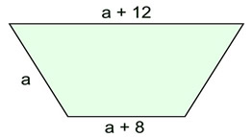](http://www.google.com/url?sa=i&rct=j&q=algebraic+expressions+perimeter&source=images&cd=&cad=rja&docid=4OSo5atkjmdsAM&tbnid=cWEwCqNx3Ok_8M:&ved=0CAUQjRw&url=http://www.regentsprep.org/Regents/math/ALGEBRA/MultipleChoiceReview/Shapes.html&ei=HHGvUZq0Mra44AOmqoDwCQ&psig=AFQjCNGVCeusqSlAX3LU8HSJhui2CjG4Bw&ust=1370538570185730)

1. What is the perimeter of this figure?
2. What is the perimeter of the figure if a=1/2 in.? Show your calculations step-by-step.
3. **Perimeter and Area of Algebraic Figures**

*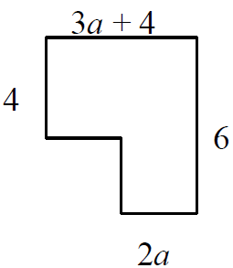A corner has been removed from this rectangle. Answer the following questions related to figure below.*

1. Find an expression for the perimeter of the rectangle.
2. What is the perimeter of the rectangle if a = ¾ inch? Show your calculations step-by-step.
3. Find an expression for the area of the rectangle.
4. What is the area of the rectangle if a = 1.8 feet? Show your calculations step-by-step.

**SE: ALGEBRA MAGIC **

**USING MATH TO PROVE ALGEBRA MAGIC TRICKS**

In the space provided, follow your teacher’s instructions for the first math trick. What did you get as a result? How does this compare to your classmates answers?

For each magic trick below, work through the trick with numbers. Then, write an expression and rewrite it to demonstrate the operation being performed in the trick.

Trick #1

|  |  |  |  |
| --- | --- | --- | --- |
| **Steps to Trick** | **Numerical** | **Expression** | **Equivalent Expression** |
| Start with a number |  |  |  |
| Double the number |  |  |
| Add 4 |  |  |
| Subtract 5 |  |  |
| Half the number |  |  |

Trick #2

|  |  |  |  |
| --- | --- | --- | --- |
| **Steps to Trick** | **Numerical** | **Expression** | **Equivalent Expression** |
| Start with a number |  |  |  |
| Add six |  |  |
| Double the Result |  |  |
| Subtract 20 |  |  |
| Subtract your original number |  |  |
| Add 8 |  |  |

Trick #3

|  |  |  |  |
| --- | --- | --- | --- |
| **Steps to Trick** | **Numerical** | **Expression** | **Equivalent Expression** |
| Start with a number. It must be a fraction. |  |  |  |
| Triple the number |  |  |
| Add $\frac{-1}{4}$ |  |  |
| Subtract twice the number |  |  |
| Add $\frac{3}{5}$ |  |  |
| Subtract the original number |  |  |

1. What properties did you have to apply in order to rewrite the algebraic expressions?
2. Create a trick with four steps that will have a result of 5. Write the algebraic expression(s) that prove it works.
3. Create a new trick with the distributive property that will result in starting and ending with the same value. Write the algebraic expression(s) to prove it works.
4. Create a trick where you start with the day of your birth and end with the month of your birth. Write a numerical expression to show each of your steps.

**Formative Assessment Lesson: Building and Solving Equations 1**

(Concept Development)

This lesson unit is intended to help educators assess how well students are able to create and solve linear equations.

*Source: Formative Assessment Lesson Materials from Mathematics Assessment Project*

<http://map.mathshell.org/materials/download.php?fileid=1362>

* This FAL is very similar to the “Algebra Magic” task. You may want to pick one or the other to use in your classroom.

**STANDARDS ADDRESSED IN THIS TASK**

**MCC7.EE.3** Solve multi-step real-life and mathematical problems posed with positive and negative rational numbers in any form (whole numbers, fractions, and decimals), using tools strategically. Apply properties of operations as strategies to calculate with numbers in any form; convert between forms as appropriate; and assess the reasonableness of answers using mental computation and estimation strategies.

**MCC7.EE.4** Use variables to represent quantities in a real-world or mathematical problem, and construct simple equations and inequalities to solve problems by reasoning about the quantities.

**MCC7.EE.4a** Solve word problems leading to equations of the form and , where , , and are specific rational numbers. Solve equations of these forms fluently. Compare an algebraic solution to an arithmetic solution, identifying the sequence of the operations used in each approach.

**STANDARDS FOR MATHEMATICAL PRACTICE**

7. Look for and make use of structure.

8. Look for and express regularity in repeated reasoning.

**COMMON MISCONCEPTIONS**

**7.EE.4** Provide multiple opportunities for students to work with multi-step problem situations that have multiple solutions and therefore can be represented by an inequality. Students need to be aware that values can satisfy an inequality but not be appropriate for the situation, therefore limiting the solutions for that particular problem.

As students begin to build and work with expressions containing more than two operations, students tend to set aside the order of operations.

**ESSENTIAL QUESTION**

* How are verbal expressions translated to algebraic expression in order to prove how an algebra “magic trick” works?
* Is there more than one way to represent a linear equation?

**TASK DESCRIPTION**

Tasks and lessons from the Mathematics Assessment Project are specifically designed to help teachers effectively formatively assess their students. The way the tasks and lessons are designed gives the teacher a clear understanding of what the students are able to do and not do. Within the lesson, teachers will find suggestions and question prompts that will help guide students towards understanding. For more information access the MAP website:

<http://www.map.mathshell.org/materials/background.php?subpage=formative>

The task, *Building and Solving Equations 1*, is a Formative Assessment Lesson (FAL) that can be found at the website: <http://map.mathshell.org/materials/lessons.php?taskid=487&subpage=concept>

The FAL document provides a clear lesson design, from the opening of the lesson to the closing of the lesson.

The PDF version of the task can be found at the link below:

<http://map.mathshell.org/materials/download.php?fileid=1362>

**SE: Geology Rocks Equations** NAME  ________________________

Mr. Anderson is a geologist and has a laboratory full of rocks. He knows that each rock weighs exactly one pound (+1), and he would like to figure out how many rocks are in each crate. To figure that out without opening the crates, Mr. Anderson places crates and rocks on a scale until they are balanced. Using his math skills, he is able to reason how many rocks are in each crate without having to look inside.

1. The following picture represents the first set of crates and rocks Mr. Anderson put on the balance. How many rocks are inside each crate?

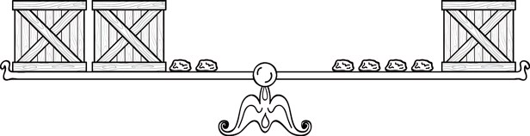

Mr. Anderson has made several picture representations on his clipboard of other combinations of crates and rocks that balanced. Can you figure out how many rocks are in each set of crates?

**.**

**2**

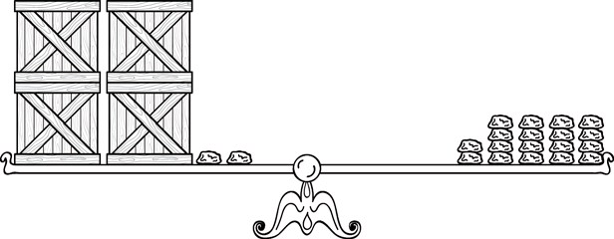

**3**

**.**

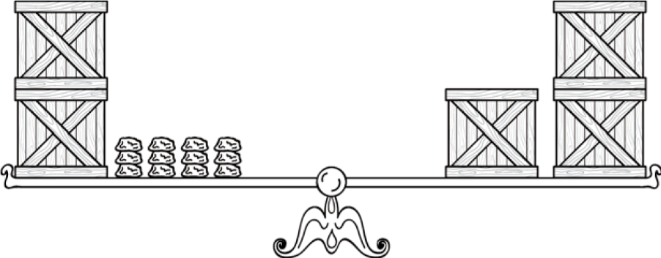

**.**

**4**

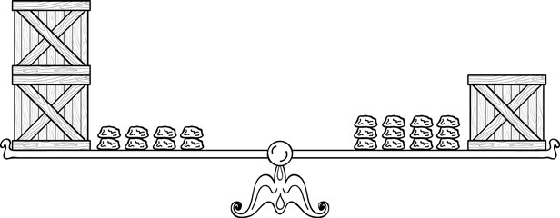

5. 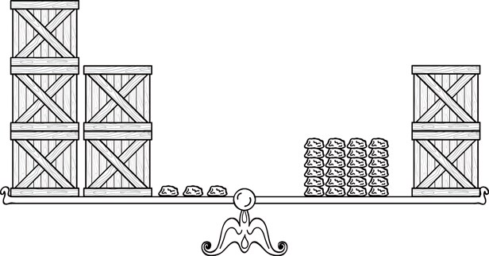

Mr. Anderson wrote down the following equations, but did not draw any pictures. Can you find the value of *x* in each? (Hint: Think of each *x* as a crate of rocks.)

1. 7*x* = 6 + 5*x*

1. 30 = 4*x* + 6

1. 2(*x* + 4) = 16

1. 7 + 5*x* = 3*x* + 13

Resources for Teaching Math

**SE Learning Task: Deconstructing Word Problems **

**Part I: Warm-Up Expressions**

For each expression below, translate the verbal expression to an algebraic expression

1) Ann has the 5 newest music CD’s which is 3 less than twice the amount that Bob has. __________________________________

2) Mike, who has 6 video games, has half as many games as Paul. ____________________________________________________

3) Nan rode the roller coaster 8 times, which was twice as many times as she rode the Ferris wheel. _______________________________

4) Janine, who bought $15 worth of make-up, spent $6 less than Leah spent. ________________________________________________

5) Rob, who has all 13 girls’ phone numbers that are in his homeroom, has 3 more than half the number of girls’ phone numbers that Jay has. _____________________________________________________

6) Kate’s 85 on her English test was 37 points less than twice the grade on her Science test. _____________________________________

7) At the Middle School Graduation Dance, the DJ played 12 slow dances, which was equal to the quotient of the number of fast dances and 2. _______________________________________________

**Part II: Creating Equations from Word Problems**

Use the chart provided in order to create expressions for the situation described in the word problem. Then, use these expressions and the word problem in order to create and solve an equation. Make sure you not only solve for the variable, but also answer the question being presented. Show all your work when solving the equations.

1. Sean sold 4 more boxes of candy for the school fundraiser than Marta. The sum of the boxes they sold was 22. How many boxes did each sell?

1. Ned weighs 1½ times as much as Jill and Tom weighs 15 kilograms more than Jill. If their combined weight is 190 kilograms, how much does each person weigh?
2. The sides of a triangular birdcage are consecutive integers. If the perimeter is 114 centimeters, what is the length of each side? Label each side with an expression that represents its length.
3. Caitlyn did 6/7 of the problems on her math quiz correctly and four incorrectly. She did all the problems. How many were there?
4. Geri spent Friday, Saturday and Sunday selling a total of 24 magazine orders for her school fundraiser. The amounts she sold, respectively, on the three days were consecutive even integers. How many did she sell on each day?

**Formative Assessment Lesson: Steps to Solving Equations**

(Concept Development)

This lesson is intended to assess how well students are able to:

* form and solve linear equations using factoring and the distributive property
* use variables to represent equations in real-world problems
* represent word problems in equivalent equations.

*Source: Formative Assessment Lesson Materials from Mathematics Assessment Project*

<https://www.georgiastandards.org/Common-Core/Documents/l61_steps_to_solving_equations_alpha_complete.pdf>

**STANDARDS ADDRESSED IN THIS TASK**

**MCC7.EE.1** Apply properties of operations as strategies to add, subtract, factor, and expand linear expressions with rational coefficients.

**MCC7.EE.2** Understand that rewriting an expression in different forms in a problem context can shed light on the problem and how the quantities in it are related.

**MCC7.EE.3** Solve multi-step real-life and mathematical problems posed with positive and negative rational numbers in any form (whole numbers, fractions, and decimals), using tools strategically. Apply properties of operations as strategies to calculate with numbers in any form; convert between forms as appropriate; and assess the reasonableness of answers using mental computation and estimation strategies.

**MCC7.EE.4** Use variables to represent quantities in a real-world or mathematical problem, and construct simple equations and inequalities to solve problems by reasoning about the quantities.

**MCC7.EE.4a** Solve word problems leading to equations of the form and , where , , and are specific rational numbers. Solve equations of these forms fluently. Compare an algebraic solution to an arithmetic solution, identifying the sequence of the operations used in each approach.

**MCC7.EE.4b** Solve word problems leading to inequalities of the form $px+q>r$ or $px+q<r$, where $p$, $q$, and $r$ are specific rational numbers. Graph the solution set of the inequality and interpret it in the context of the problem.

**STANDARDS FOR MATHEMATICAL PRACTICE**

1. Make sense of problems and persevere in solving them.

2. Reason abstractly and quantitatively.

6. Attend to precision.

**ESSENTIAL QUESTIONS**

* How are properties of operations applied in order to generate equivalent expressions and/or equations?
* What are some strategies for solving real life mathematical problems involving numerical and algebraic equations and expressions?

**TASK COMMENTS**

Tasks and lessons from the Mathematics Assessment Project are specifically designed to help teachers effectively formatively assess their students. The way the tasks and lessons are designed gives the teacher a clear understanding of what the students are able to do and not do. Within the lesson, teachers will find suggestions and question prompts that will help guide students towards understanding. For more information access the MAP website:

<http://www.map.mathshell.org/materials/background.php?subpage=formative>

The PDF version of the task can be found at the link below:

<https://www.georgiastandards.org/Common-Core/Documents/l61_steps_to_solving_equations_alpha_complete.pdf>

**SE LEARNING TASK: T.V. Time and Video Games** 

An inequality is a math sentence that compares two quantities. Often one of the quantities is a variable. Use the following symbols and descriptions to represent each type of inequality.

< means “is less than.” $≤$ means “is less than or equal to.”

> means “is greater than.” $≥$ means “is greater than or equal to.”

$≠$ means “is not equal to.”

How could you represent each inequality below?

1. Nima will spend less than $25 ___________________________
2. Derrick ran at least 30 miles last week _____________________
3. Kia needs at least $200 to buy the TV she wants ________________

Kia volunteers with some friends at a community center. While shopping online for a new television she decides she wants one with at least a 26 in. screen. Using the chart below, write an inequality to show how much money the center will have to spend.

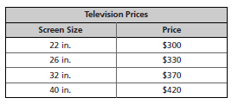Inequality ______________________

1. Graph the inequality on the number line.



1. Kia wants to have money left over. How can the graph be changed to show they need to have more than $330?
2. The center has a stand for the television that will hold up to 30 lb of weight. Draw a graph to show how much the television she buys can weigh.



Kia plans to use money from the community center’s savings account to buy a gaming system. There must be $129 left in the savings account after she withdraws what she needs.

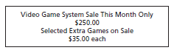

1. Write and solve an inequality to represent the situation, where x represents the amount of money the center has in its savings account.
2. Graph the possible values from the solution found in number seven.



The community center rents rooms for an hourly rate, plus a set-up fee.

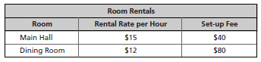

1. A school group has $140 to spend. Write and solve an inequality that represents the cost to rent the main hall, where *h* represents the number of hours the group can rent the room.
2. The same group is also considering renting the dining room. Write and solve an inequality to represent this situation.
3. Use your solutions from 9 and 10 to justify your selection of which room the group should rent.

The community center has $175 to spend on video games for its new gaming system. Games are on sale for $35 each.

1. Write and solve an inequality to represent the number of games the center could buy. Explain your solution in reference to the problem.
2. Graph the solution on a number line.



The center is considering signing up for an online game-rental service rather than buying the games. The table shows equipment cost and monthly fees for two services.

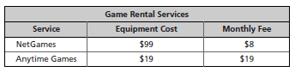

1. Write and solve an inequality that represents the number of months the center could rent games from NetGames with its $175. Explain the solution in terms of the problem.
2. Write and solve an inequality to represent the number of months the center could rent games from Anytime Games. .Explain the solution in terms of the problem.
3. Use your answers from 14 and 15 to justify which service the community center should purchase.